Research Article, Review
Title
Elsa Roos ^{1,⸸}, Catherine Holliday ^{2, ⸸} and Anthony Murray ^{2,*}
¹ Affiliation 1; e-mail@e-mail.com
² Affiliation 2; e-mail@e-mail.com
⸸ these authors contributed equally to this work

* Correspondence: e-mail@e-mail.com
Abstract: The abstract should be no more than 200 words, without subheadings nor references. It should be a single paragraph, clear and concise, and should provide: a brief statement of the purpose of the study; the main methods used; the principal results; and major conclusions. Abbreviations should be avoided when not essential.
Keywords: keyword 1; keyword 2; keyword 3 (Up to 6 keywords related to the actual work, that will be associated with your manuscript)

Received: date; Accepted: date: Published: date

Introduction
The introduction should be succinct, with only the background information needed to understand the purpose of the study, without subheadings, and includes references in numerical order (in order of appearance in the text; can be in any style or format as long as the style is consistent).

Materials and Methods
Please provide subheading for this section. The authors should include sufficient detail to allow others researchers to replicate the study or build on published results. New methods should be included in detail. For well-established methods, authors may cite appropriate references, however they should include a brief but sufficient description to allow the reader to understand the results. Please give, if any, the registered clinical trial number, and the name and version of any software used. Please include required ethics statements if human or animal subjects and/or tissue were used in the actual work.

Subheading. Subheading should be specific and reflect information.

Results
This section can include subheading.

Subheading. Subheading should be specific and reflect information about the finding. For example, use “Inhibition of protein X promotes stability of protein Y” instead of “Analysis of the effect of protein X inhibition on the stability of protein Y”. This also applies to figure titles.
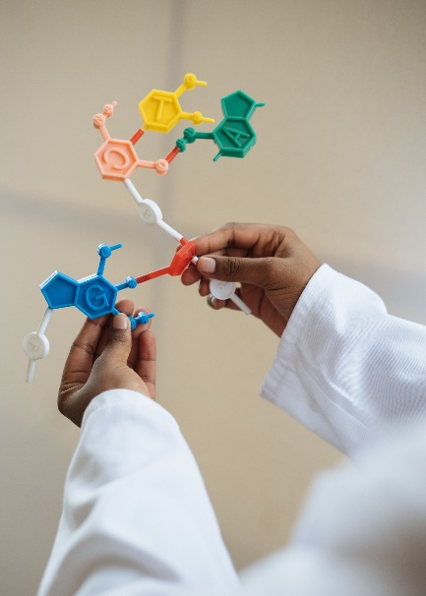
Figure 1. Figures should be embedded within the text, numbered in the order of citation in the text. We also require that each figure and table is submitted as a separate file. High resolution images (including chemical structure), with a minimum of 300 dpi at their appropriate size, are required. Use the following format for citations: Fig. 1A, B or Figs 1, 2. Please provide a title and concise legend below each figure, followed by a description of each panel.

Table 1. Tables should be embedded within the text, numbered in the order of citation in the text. Use the following format for citations: Fig. 1A, B or Figs 1, 2 or Table 1. Please provide a title at the top of each table, smaller fonts no less than 8 points in size may be used.
Entry 1 | Entry 2 (±SD) | Entry 3  (±SD)
entry 1 | data | data
entry 2 | data | data
¹ Include, below the table, footnotes or legend.

The text continues here.

Discussion
In this section, the authors must explain the significance of the results and their integration in the current state of knowledge, as well as future perspectives.

Acknowledgments
Please include funding source and grant numbers, as well as non-authors contribution (e.g. assistance in writing, proofreading, reagents, technical assistance).

Author Contributions
Only authors that have made substantial contribution to the work should be included. Please specify the individual contributions of the authors to the paper, indicating the relevant roles. For example, AB conceived and designed the work, CD performed the experiments, AB and EF drafted the manuscript. All authors read and approved the final manuscript.

Conflicts of interest
All authors must disclose any financial interests and personal relationships which may be considered as potential competing interests. Authors without financial or competing interests should explicitly include the statement ‘The authors declare no competing interests’.

References
References are placed at the end of a sentence in numerical order within square brackets, in order of appearance in the text, and listed in numerical order at the end of the paper. References can be in any style or format as long as the style is consistent. Author(s) name(s), journal title / book title, article title, year of publication, volume & issue / book chapter and the pagination must be present. The reference style required by the journal will be applied to the published version by IUCS-CESPU publishing. Inclusion of DOIs in all journal article references is encouraged.

1. Silva, P.; Barbosa, J.; Nascimento, A. V; Faria, J.; Reis, R.; Bousbaa, H. Monitoring the Fidelity of Mitotic Chromosome Segregation by the Spindle Assembly Checkpoint. Cell Prolif. 2011, 44, 391–400, doi:10.1111/j.1365-2184.2011.00767.x.

In Scientific Letters, articles are published under a CC-BY license (Creative Commons Attribution 4.0 International License at https://creativecommons.org/licenses/by/4.0/), the most open license available. The users can share (copy and redistribute the material in any medium or format) and adapt (remix, transform, and build upon the material for any purpose, even commercially), as long as they give appropriate credit, provide a link to the license, and indicate if changes were made (read the full text of the license terms and conditions of use at https://creativecommons.org/licenses/by/4.0/legalcode).

